- What is the output of the following program?

#include <iostream.h>

void main () {
int x = 1; // declare and initialize variable

for ( ; ; ) { // endless loop
if ((x++ % 15) == 0) // first test if (x % 15 = 0),
// then increment "x" by 1
break; // if true exit from loop

if ((x % 5) != 0) // test if (x % 5 != 0)
continue; // if true skip remaining code

cout << x << " "; // display "x"
}

cout << endl;
}

Answer:

If we had: if ((++x % 15) == 0) then the answer would be:

- What is the output of the following program?

#include <iostream.h>

void main () {
int x = 10; // declare and initialize variable

while ( x ) { // loop 10 times
if ( --x == 5 ) // first decrement "x" by 1,
// then test if it is equal to 5
break; // if true exit from loop

cout << x << " "; // display "x"
}

cout << endl;
}

Answer:

If we had: if(x-- == 5) then the answer would be:

- What is the output of the following program?

#include <iostream.h>

void main () {
int x = 10; // declare and initialize variable

while ( x ) { // loop 10 times
cout << --x << " "; //decrement "x" by 1 then display it
}

cout << endl;
}

Answer:

If we had: cout << x-- << " "; then the answer would be:

- What is the output of the following program?

#include <iostream.h>
void main () {
int j; // declare variable

for ( j = 1; j <= 10; j++ ) { // loop 10 times
if ( (j > 5) && (j <= 7) ) // if condition true then
cout << j << endl; // display "j"
}

cout << endl;
}

Answer:

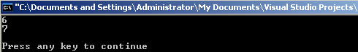

- What is the output of the following program?

#include <iostream.h>
void main () {
int j; // declare variable

for ( j = 1; j <= 10; j++ ) { // loop 10 times
if ( (j > 5) || (j <= 7) ) // if condition true then
cout << j << endl; // display "j"
}

cout << endl;
}

Answer:

- What is the output of the following program?

#include <iostream.h>
void main () {
int j; // declare variable

for ( j = 1; j <= 10; j++ ) { // loop 10 times
if ( (j < 5) || (j >= 7) ) // if condition true then
cout << j << endl; // display "j"
}

cout << endl;
}

Answer:

- What is the output of the following program?

#include <iostream.h>
void main () {
int j; // declare variable

for ( j = 1; j <= 10; j++ ) { // loop 10 times
if ( !((j < 5) || (j >= 7)) ) // if condition true then
cout << j << endl; // display "j"
}

cout << endl;
}

Answer:

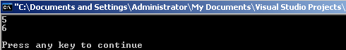

- What is the output of the following program?

#include <iostream.h>

void main () {
int i, j, k; // declare variables

for ( i = 1; i <= 2; i++ ) // loop 2 times
for ( j = 1; j <= 2; j++ ) // loop 2 times
for ( k = 1; k <= 3; k++ ) // loop 3 times
cout << k << " "; // display "k"

cout << endl << endl;
}

Answer:

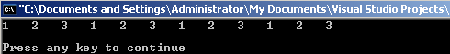

- What is the output of the following program?

#include <iostream.h>

int main () {
int count = 0; // declare and initialize variable

while ( count++ <= 5 ) // loop 5 times
// if (count % 2) is true, display "***", else display "---"
cout << ( count % 2 ? "***" : "---" ) << endl;

cout << count << endl << endl; // display "count"

return 0;
}

Answer:

If we had:
cout << (count % 2 == 0 ? "***" : "---") << endl;

Then the answer would be:

- What is the output of the following program?

#include <iostream.h>

int main () {
int j = 10, b = 5; // declare and initialize variables

for ( ; b <= j; j -= 1 ) { // loop 3 times
if ( (j%b == 0) && (j*5 <= 25) ) // if condition true
continue; // skip remaining code

if ( (j < 7) || (j >= 9) ) // if condition true
cout << j << endl; // display "j"
}

cout << endl;

return 0;
}

Answer:

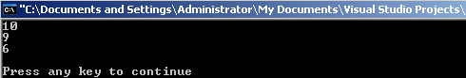

- What is the output of the following program?

#include <iostream.h>

void main () {
for ( int i = 45; i > 1; i = i / 5 ) // loop 3 times
cout << i++ << endl; // display "i", then increment it
cout << "continue"; // display the word "continue"

cout << endl << endl;
}

Answer:

- What is the output of the following program?

#include <iostream.h>

void main () {
int i, j, k; // declare variables
int x = 0; // declare and initialize variable

for ( i = 1; i <= 5; i++ ) // loop 5 times
for ( j = 1; j <= 7; j += 2 ) // loop 4 times
for ( k = 1; k < 15; k += 3 ) // loop 5 times
x++; // increment "x" by 1

cout << x << endl << endl; // display "x"
}

Answer:

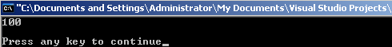

- What is the output of the following program?

#include <iostream.h>

void main() {
int x; // declare variable

for (x = 1; x <= 5; x++) { // loop 5 times

switch (x) { // switch value of "x"
case 1: // if "x" is equal to 1, then
cout << x << endl; // display "x", but don’t break

case 2: // if "x" is equal to 2, then
cout << x << endl; // display "x", but don’t break

case 3: // if "x" is equal to 3, then
cout << x << endl; // display "x"
break; // break from switch structure

default: // if "x" is # from 1,2,3, then
cout << x + 1 << endl; // display "x +1"
}
}

cout << endl;
}

Answer:

